Vocab List:
- Chalazion- oil gland inflammations that occur on the eyelids. Oil gland gets blocked, causes redness and inflammation. We often drain these
- Lesion- Abnormal lumps, bumps or growths that occur close to the eyes and can either be benign or cancerous. We often biopsy these
- Giant cell arteritis- causes inflammation of certain arteries, especially those near the temples. The most common symptoms of giant cell arteritis are head pain and tenderness — often severe — that usually affects both temples. (Same as temporal arteritis)
- Temporal arteritis- inflammation and damage to blood vessels that supply the head area, particularly the large or medium arteries that branch from the neck. It is most common in the head, however it can affect medium to large arteries throughout the entire body. In some cases, paralysis of eye muscles can occur.
- Dermatochalasis- a condition where there is excess skin of the upper eyelids. This is can visually obstructive if severe or may be cosmetic in nature. Where the skin is drooping over the eyelid.
- Ptosis- Also known as blepharoptosis, this condition is characterized by droopy upper eyelids. Where the muscle of the eyelid relaxes, causing the eyelid to droop
- Ectropion- A condition that occurs when the lower eyelid rolls outward and droops away from the eye.
- Entropion- A condition characterized by the inward turning of the upper or lower eyelid, causing eyelashes to rub against the eyeball.
- Dacryocystitis- infection of the lacrimal sac, a small chamber into which tears drain. The usual cause of dacryocystitis is a blockage of the nasolacrimal duct, which leads from the lacrimal sac into the nose. Dacryocystitis may occur suddenly (acute) or be longstanding (chronic). In acute infection, the area around the lacrimal sac is painful, red, and swollen. The eye may become red and watery and may ooze pus.
- Lacrimal Gland- What produces tears
  - 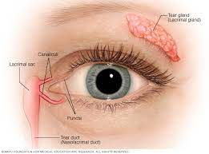
- Punctum- Opening of tear duct
- Epiphoria- Excessive tearing
- Obstructed tear ducts – Blockage of the tear ducts either from birth, injury, illness, or other problems with tear production.
- Thyroid Eye Disease (TED)- Bulging or swelling of the surrounding eye tissues due to overactive thyroid caused by Graves’ disease.
- Orbital Mass- abnormal growths of tissue in the structures that surround the eye. We remove these. Often are fat deposits
  - 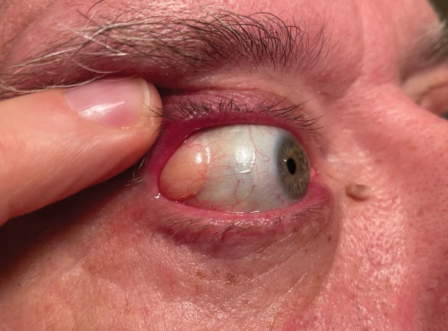
- Blepharitis- common eye condition that causes inflammation of the eyelids. It can cause the eyelids to appear red, swollen, or feel sore or burning. Blepharitis can also cause dandruff-like flakes to form on the eyelashes.
- Meibomian Gland Dysfunction (MGD)- a common condition that occurs when the meibomian glands don't produce enough oil (meibum), or the oil is of poor quality. MGD is a common underlying cause of dry eye syndrome and blepharitis. Do lipiflow for
- Trichiasis- Trichiasis is a medical term for misdirected eyelashes that grow toward the eye, sometimes touching the cornea or conjunctiva. Severe cases may cause scarring of the cornea
- Hyfrecation- performed with a small needle with an electrical pulse which acts as a diathermy to burn away tiny and undesired lumps and to get rid of eyelashes causing trichiasis
- Brow Ptosis- The lowering of the eyebrow from its normal anatomical position to a point where it is cosmetically unattractive, or vision field deficiencies emerge due to extra soft tissue pushing downward on the eyelid.
- Blepharospasm- Spasms of the muscle(s) around the eye. We do botox injections for this
- Basal Cell Carcinoma (BCC)- the most common form of skin cancer
- Orbital Fracture- Fracture of the bones around the eye
- Canaliculitis- inflammation of the tear drainage passageways within the eyelids. It may cause tearing, discharge, red eye, and mild tenderness
- Steatoblepharon- condition where the eyelid fat pads become prominent. Bags under eyes
- Eyelid retraction- Eyelid retraction is when the upper eyelid is too high or the lower eyelid is too low. It can cause the eye to be irritated, red or dry. It can be caused by scarring from previous surgery, thyroid eye disease or aging.
- Exophthalmos- protruding eyeball anteriorly out of the orbit (eye socket). Exophthalmos can be either bilateral (both eyes bulge out) or unilateral (just one eye bulges out). Doctors use an exophthalmometer to measure the degree of exophthalmos. TED or Tumor behind eye patients
- Facial Nerve Palsy- Facial Nerve Palsy is a nervous system disorder in which a damaged nerve in the skull affects the movement of the muscles of the face. It can affect vision and closing one eye and can change the appearance of the face
- Lagophthalmos- the eyelid will not completely close. When the eye does not close completely or blink, the eyes don’t get the thin layer of tear fluid.
- Squamous Cell Carcinoma- second most common form of skin cancer.

